# Continuous Time Transfer function - Lead/Lag:

$$C\left(s\right)= \frac{ατs+1}{τs+1}$$

$α>1$ implies it is a lead controller, $α<1$ implies a lag controller.

# Forward Euler

Substituting,

$$s=\frac{z-1}{T}$$

We get,

$$C\left(z\right)= \frac{ατ\left(z-1\right)+T}{τ\left(z-1\right)+T}= \frac{U}{E}$$

Converting to difference equations,

$$τ.u\left(k+1\right)=ατ.e\left(k+1\right)+\left(T-ατ\right).e\left(k\right)-\left(T-τ\right).u\left(k\right)$$

Using the time-shift property, taking $τ$ to the right-hand side,

$u\left(k\right)=α.e\left(k\right)+\left(\frac{T}{τ}-α\right).e\left(k-1\right)- \left(\frac{T}{τ}-1\right).u\left(k-1\right)$

**LabVIEW implementation:**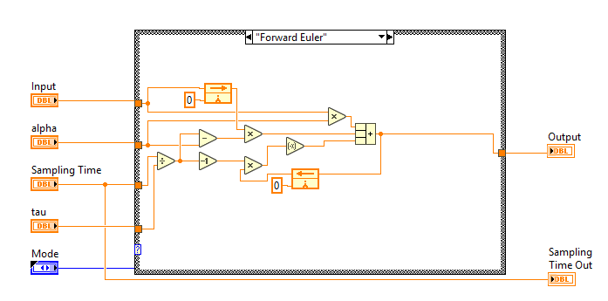

# Backward Euler

Substituting,

$$s=\frac{z-1}{Tz}$$

We get,

$$C\left(z\right)= \frac{ατ\left(z-1\right)+Tz}{τ\left(z-1\right)+Tz}= \frac{U}{E}$$

Converting to difference equations,

$$\left(τ+T\right).u\left(k+1\right)=\left(ατ+T\right).e\left(k+1\right)-ατ.e\left(k\right)+τ.u\left(k\right)$$

Using the time-shift property, taking $(τ+T)$ to the right-hand side,

$$u\left(k\right)=\left(\frac{ατ+T}{τ+T}\right).e\left(k\right)-\left(\frac{ατ}{τ+T}\right).e\left(k-1\right)+ \left(\frac{τ}{τ+T}\right).u\left(k-1\right)$$

**LabVIEW implementation:**

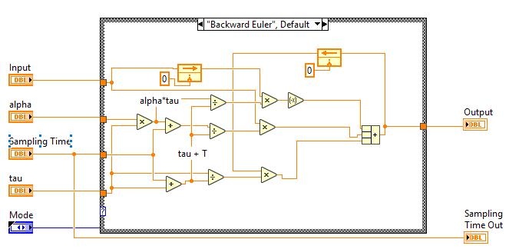

# Trapezoidal / Bi-linear / ‘Tustin’

Substituting,

$$s=\frac{2}{T}∙\frac{z-1}{z+1}$$

We get,

$$C\left(z\right)= \frac{2ατ\left(z-1\right)+T(z+1)}{2τ\left(z-1\right)+T(z+1)}= \frac{U}{E}$$

Converting to difference equations,

$$\left(2τ+T\right).u\left(k+1\right)=\left(2ατ+T\right).e\left(k+1\right)+\left(T-2ατ\right).e\left(k\right)-(T-2τ).u\left(k\right)$$

Using the time-shift property, taking $(T+2τ)$ to the right-hand side,

$$u\left(k\right)=\left(\frac{T+2ατ}{T+2τ}\right).e\left(k\right)+\left(\frac{T-2ατ}{T+2τ}\right).e\left(k-1\right)- \left(\frac{T-2τ}{T+2τ}\right).u\left(k-1\right)$$

**LabVIEW implementation:**

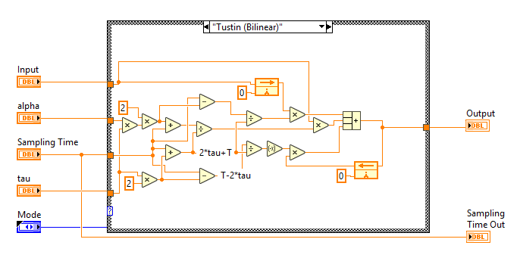

# Continuous Time Transfer function - Integrator:

$$C\left(s\right)= \frac{K_{I}}{s}= \frac{1}{T_{i}s}$$

# Forward Euler

Substituting,

$$s=\frac{z-1}{T}$$

We get,

$$C\left(z\right)= \frac{K_{I}T}{z-1}= \frac{U}{E}$$

Converting to difference equations,

$$u\left(k+1\right)=K_{I}T.e\left(k\right)+u\left(k\right)$$

Using the time-shift property, taking $τ$ to the right-hand side,

$$u\left(k\right)=K_{I}T.e\left(k-1\right)+ u\left(k-1\right)$$

**LabVIEW implementation (with anti-windup):**

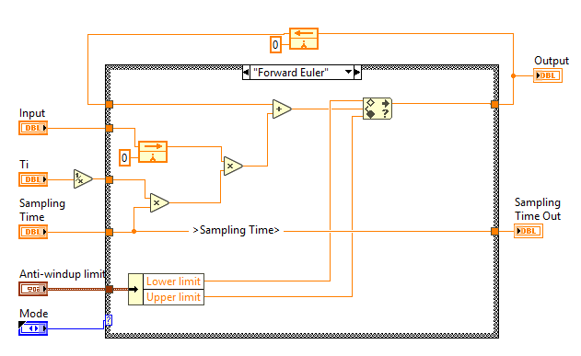

# Backward Euler

Substituting,

$$s=\frac{z-1}{Tz}$$

We get,

$$C\left(z\right)= \frac{K_{I}Tz}{z-1}= \frac{U}{E}$$

Converting to difference equations,

$$u\left(k+1\right)=K_{I}T.e\left(k+1\right)+u\left(k\right)$$

Using the time-shift property, taking $τ$ to the right-hand side,

$$u\left(k\right)=K_{I}T.e\left(k\right)+ u\left(k-1\right)$$

**LabVIEW implementation (with anti-windup):**

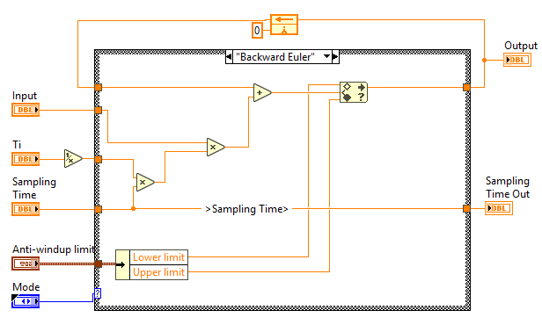

# Trapezoidal / Bi-linear / ‘Tustin’

Substituting,

$$s=\frac{2}{T}∙\frac{z-1}{z+1}$$

We get,

$$C\left(z\right)= \frac{K_{I}T}{2}.\frac{z+1}{z-1}= \frac{U}{E}$$

Converting to difference equations,

$$u\left(k+1\right)=\frac{K_{I}T}{2}.\left\{e\left(k\right)+\left.e\left(k+1\right)\right\}\right.+u\left(k\right)$$

Using the time-shift property, taking $τ$ to the right-hand side,

**LabVIEW implementation (with anti-windup):**

